Perinatal PTSD |  | Unfold Your Wings
What is Perinatal PTSD?  Post-traumatic stress disorder (PTSD) is the clinical term for a set of reactions to a traumatic, distressing experience or event. It can occur after a person experiences or witnesses something that was, or they perceive to have been, life threatening. In the perinatal period this can be due to a difficult pregnancy, traumatic birth or a sick/premature baby.  Signs of Perinatal PTSD?  - Feelings of intense fear, helplessness and/or terror  - Re-experiencing the event by intrusive thoughts, flashbacks and/or nightmares.  - Feeling distressed, anxious or panicky when exposed to something which reminds them of the event.  - Avoidance of anything that reminds them of the trauma. This can include talking about it, going to or near the place where the trauma happened, or people that may have been involved in the trauma, such as hospitals, doctors, healthcare professionals.  - Difficulties with sleeping or concentrating, thus affecting daily activities.  - Feelings of anger, irritability and/or hyper-vigilance or jumpy, and easily startled.  - Panic attacks, depression or/and anxiety.  - Dissociation can occur. This is a disconnection between a person’s thoughts, memories, feelings, actions, or sense of who he or she is. This can involve “losing touch” with awareness of one’s immediate surroundings and can happen during flashbacks.  Some women find their birth experience triggers, or can add to, a previous trauma such as rape or childhood abuse.  Help to recover  - Don’t suffer in silence. Speak to someone you trust, partner, friends/family  - Look after yourself physically, rest, a balanced diet and gentle exercise such as yoga  - Ask for help. Your GP, midwife or health visitor can support you to access therapies that can help you to heal  - Learning relaxation and breathing techniques can help to lower your body’s fight or flight reaction to trauma  - Find local support groups or support groups on social media such as the Birth Trauma Association Facebook group |  | 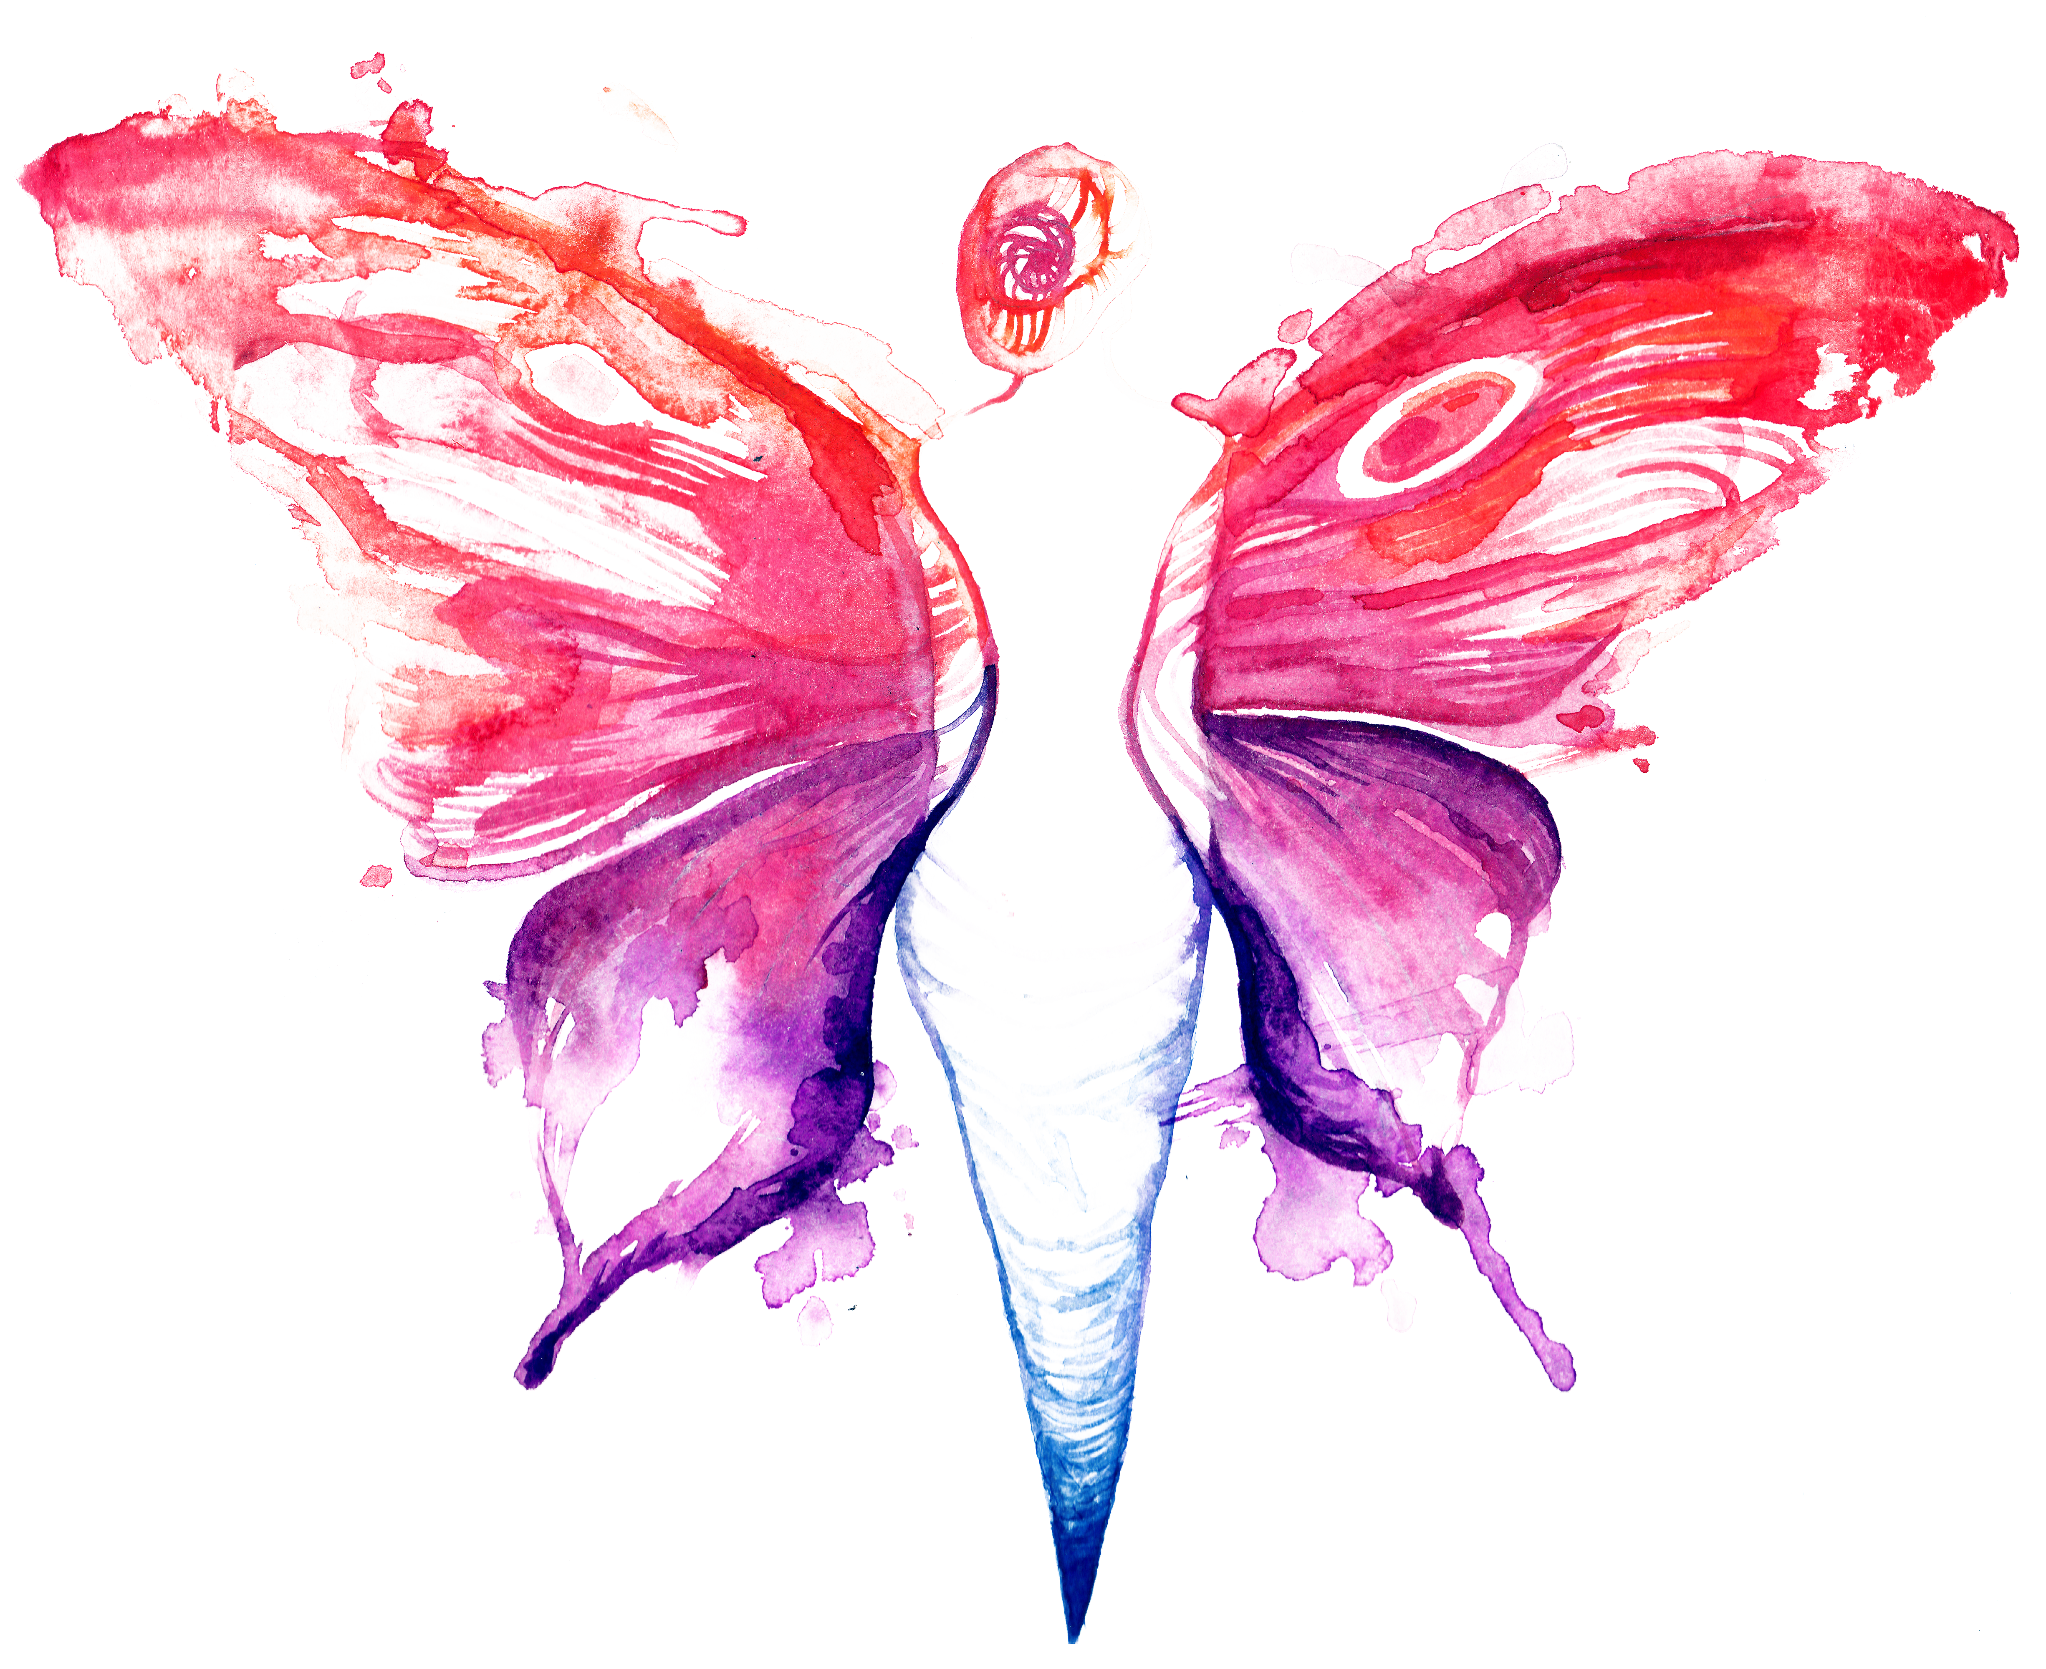  Treatment of Perinatal PTSD  - Trauma -Focused Cognitive Behavioural therapy (CBT)  - Eye Movement Desensitization and reprocessing (EMDR)  - Somatic therapies  - Counselling  - Medication  Other support;  - journaling  - learning about PTSD  - grounding techniques  - debriefing/birth reflection sessions  Remember  - You are not alone  - PTSD can be treated  - With the right support you will recover  Support  Birth Trauma Association  EMDR Institute  MIND

